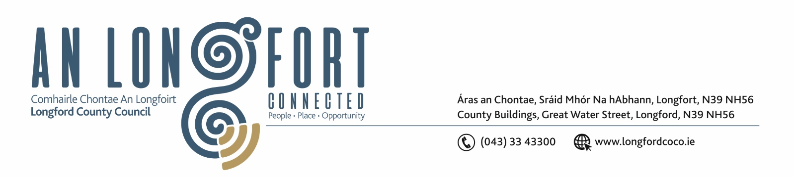

Minutes of Statutory Budget Meeting of Longford County Council
held in Council Chamber and via MS Teams on
Monday, 04 December 2023 at 4pm
____________________________________________________________________

PRESIDING: Cathaoirleach Councillor Colm Murray

MEMBERS PRESENT: Councillors – Uruemu Adejinmi, Paraic Brady, Seamus Butler, Mick Cahill, Mark Casey, Colin Dalton, Martin Monaghan, Peggy Nolan, Garry Murtagh, Paul Ross, Pat O’Toole, Gerard Farrell, Gerry Hagan, PJ Reilly, Gerry Warnock, Councillor John Browne and Turlough McGovern

APOLOGIES: None

IN ATTENDANCE: Mr. Paddy Mahon, Chief Executive
Mr. John McKeon, Head of Finance
Mr. John Brannigan, Director of Services
Ms. Barbara Heslin, Director of Services
Ms. Samantha Healy, Director of Services

MEETINGS
ADMINISTRATOR: Mr. Gerard Dennigan

Introduction by the Head of Finance.

Mr. John McKeon, Head of Finance, thanked the Members for their attendance at the Statutory Budget meeting and stated that the presentation prepared will give an overview on how the Budget for 2024 was prepared. The Budget for 2024 for each Service Division will be presented in turn, allowing the Members to raise specific questions on each Division.

John stated that we have had very challenging years however, 2024 will also see us facing more significant challenges.

John acknowledged the significant support to Longford County Council to compensate for the loss of rates from the closure of the Lanesboro Power Station.

John thanked the Cathaoirleach and Members of the Council for their continued co-operation and support and also thanked his team in the Finance Directorate, the Directors of Services, and their teams for the huge amount of work carried out in preparing the Draft Budget.

John McKeon, Head of Finance, stated that expenditure for 2024 is estimated at
€69.7m and income of €49.95m which in total will leave a shortfall of €19.78m to be funded through Local Property Tax and Rates.

John outlined the details of the Draft Budget for 2023 under the following headings –

- Budget Book Structure.
- Financial Position
- Challenges & Solutions for 2024
- Financial Position – start of 2023
- Acute Financial Challenges 2024
- Budget Assumptions for 2024
- Local Property Tax
- Equalisation Fund Allocation
- Local Government Fund
- Commercial Rates
- Income and Expenditure 2024
- Sources of Income
- Income Configuration
- Expenditure by Service Division
- Expenditure Variance by Service Division
- Table D – Income from Goods and Services
- Table E – Income from Grants and Subsidies
- Table F – Analysis of Expenditure and Income by Service Division
- Lanesborough Power Station Lost Commercial Rates Income

The likelihood of a deficit for 2023 was also highlighted, this would be mainly attributed to the Budgeted Rent Review for 2023, not being implemented on time.

Budget 2024 – Headline Metrics

- Budget Expenditure increased by nearly €5.28m for 2024

- €69.7m Budget means:
- €1,492 spend per citizen
- €4,054 spend per LPT payer
- €45,997 spend per rate payer

Budget 2024 – Highlights

- Record Revenue Budget of nearly €70m for 2023
- No Commercial Rates Increased proposed
- Central Government subsiding lost rates income from Lanesborough Power Station (2024)
- General Municipal allocations increased by €30k for 2024
- Service Levels maintained and enhanced in some areas.
- No change in local property tax rates from 2022
- No Vacant Property Levey Proposed
- Reasonable expectation of continued government support
- ‘Business as usual’ approach for all Regeneration projects
- Local Roads, Housing Maintenance, Walkways and Drainage Budgets all increased for 2024

The Executive replied to the issues raised by the Members, including the following –
- Maintenance of Local Authority housing
- Derelict Sites Levy
- Burial Grounds
- Recreational & Amenities – Playgrounds, Walkways & Harbours
- Members’ County Wide Fund
- Rates
- Service Support
- Income
- Litter Bins
- Construction Costs
- River Drainage
- Dog Warden Service
- Regeneration projects
- Civic Offices
- Rent Review
- Tourism
- IDA Site
- Unfinished Housing Estates
- The emerging shortfall from Housing Voids departmental funding.
- Public Conveniences.
- Uisce Eireann ‘Stranded Costs’.
- Pension Costs.

Head of Finance, John McKeon responded to questions raised by the members.

The members unanimously acknowledged the comprehensive budget prepared and delivered by the Head of Finance and the Finance team in Longford County Council.

On the proposal of Councillor Paul Ross and Seconded by Councillor Seamus Butler the Budget for 2024 was unanimously adopted by the elected members.

Chief Executive Paddy Mahon, thanked the Members for their attendance, he thanked them for their continued support and the ambitions they have for County Longford. Paddy thanked John McKeon, the Finance Team and the Management Team in Longford County Council for all their work in preparing the Budget for 2024.

This concluded the business of the meeting.

Signed: ______________________
Gerard Dennigan
A/Meetings Administrator.

Confirmed and adopted at Monthly Meeting of Longford County Council held on the
XX January 2024.

Signed: _______________
Cathaoirleach.

